Project Report

On

**HOSTEL**

**MANAGEMENT SYSTEM**

Submitted by

221FA20017

S.Sri Kavya



Bachelor of Technology(B.Tech)

in

Computer Science and Business systems

**CERTIFICATE OF ACCEPTANCE**

This is to certify that **SWARNA SRI KAVYA** bearing Registration No.221FA20017 of Advanced Computer Science Engineering,VFSTR has worked on the project entitled “HOSTEL MANAGEMENT SYSTEM” under the supervision of Dr. Amarendra, Assistant Professor, Advanced Computer Science Engineering,VFSTR deemed to be Universitym, Vadlamudi..

The project was carried outduring the 3rd year first semester.The project is hereby accepted by the Advanced Computer Science Engineering,VFSTR, in partial fulfilment of the requirements for the award of B.Tech Degree in CSBS.

**COURSE COORDINATOR**

**Advanced Computer Science Engineering**

**VFSTR**

**DECLARATION**

I hereby certify that the work which is being presented in the project entitled “HOSTEL MANGEMENT SYSTEM” in partial fulfillment of requirements for the award of degree of B.Tech (CSBS) submitted in the Department of Advanced Computer Science and Engineering at

Vignan’s Foundation for Science, Technlogy and Research University, is an authentic record of my own work carried out under the supervision of Dr. AMARENDRA, Assistant Professor, Vignan’s Foundation for Science, Technlogy and Research University, Guntur, Andhra Pradesh, India.

The matter presented in this project has not been submitted by me in any other University / Institute for the award of B.Tech Degree.

Name:S.Srikavya

Reg no: 221FA20017

**ABSTRACT**

As the name specifies “HOSTEL MANAGEMENT SYSTEM” is a software developed for managing various activities in the hostel. For the past few years the number of educational institutions are increasing rapidly. Thereby the number of hostels are also increasing for the accom- modation of the students studying in this institution. And hence there is a lot of strain on the person who are running the hostel and software’s are not usually used in this context. This particular project deals with the problems on managing a hostel and avoids the problems which occur when carried manually. Identification of the drawbacks of the existing system leads to the designing of computerized system that will be compatible to the existing system with the system Which is more user friendly and more GUI oriented. We can improve the efficiency of the system, thus overcome the drawbacks of the existing system.

· Less human error

· Strength and strain of manual labour can be reduced

· High security

· Data redundancy can be avoided to some extent

· Data consistency

· Easy to handle

· Easy data updating

**Contents**

**1.Introduction   
1.0.1 Aim** -1.2 Project Overview

- 1.3 Problem Statement

- 1.4 Objectives

- 1.5 Limitations

**2.Background Knowledge** - 2.1 Existing Systems

- 2.2 Disadvantages of Existing Systems

- 2.3 Advantages of Proposed System

**3.** **Feasibility Study**

- 3.1 Technical Feasibility

**4. Requirement Analysis and Specification**

-4.1 UserModule

-4.2 StudentModule

-4.3 RoomAllotmentModule

-4.3.1 RoomFeesModule

-4.4 ReportGenerationModule

**5. Hardware Configuration**

**6. Software Requirements**

- 6.1 HTML

- 6.2 CSS

- 6.3 JavaScript

- 6.4 PHP

- 6.5 Apache Server (XAMPP)

- 6.6 Bootstrap

- 6.7 MySQL Database Server

**7. Results and discussions**

-7.1 StudentnLog-inpage

-7.2 StudentRegistration

-7.3 Dashboard

-7.4 UserBlockDetails

-7.5 Fee payment

-7.6 Alloting mess blocks

-7.7 User profile

-7.8 AdminLogininpage

-7.9 AdminManageRoom

-7.9.1 Attendance Room

-7.9.2 Student details

-7.9.3 Admin profile

**8. Conclusion**

**9. Future Work**

**10. Bibliography**

**INTRODUCTION**

We have got nine hostels in our university, which consist of four boy’s hostel and five girl’s hostel. All these hostels at present are managed manually by the hostel office. The Registration form verification to the different data processing are done manually. Thus there are a lot of repetitions which can be easily avoided. And hence there is a lot of strain on the person who are running the hostel and software’s are not usually used in this context.This particular project deals with the problems on managing a hostel and avoids the problems which occur when carried manually Identification of the drawbacks of the existing system leads to the designing of computerized system that will be compatible to the existing system with the system which is more user friendly and more GUI oriented. We can improve the efficiency of the system, thus overcome the drawbacks of the existing system.

**Aim**  
“To manage room booking and students information in hostel using this web based  
software”.

**PROJECT OVERVIEW**The aim of the Hostel Management System is to do all the activities of Hostel in a systemic way. It is a web based software to provides college students accommodation to the university hostel more efficiently. It is headed by Warden. Who will be the administrator .This project keeps details of the hostellers and applied students .The main theme of this project is to minimize human works and makes the hostel activities more easier. This project providing online application for hostel, automatically select the students from the waiting list and mess calculation, registration..etc  
**1.2 PROBLEM STATEMENT**  
The Hostel Management System is developed for advancing the activities of the hostel.The main benefit of the software is to remove manual system. Since most hostels are being run by only one hostel manager. The number of students in a room, the students who owe to the hostel etc are saved on papers or sometimes receipts. If these documents should go missing or stolen, one would never be able to know .The employees might not know the number of students in a room or know if a room is full or not. This project will be great relief to the employees. This will help to carry out the activities of Hostel in an efficient way.

**1.2.1 Goal**The hostels handle the entire information manually, which is very tedious and mismanaged.  
• The objective of our project is as follows.  
• To keep the information of students.  
• To keep all detail in brief like block information and total number of students.  
**1.3 OBJECTIVES**  
• To automate each and every activity of the manual system.  
• To make it easier for data collection, storage and referencing reliable.  
• To store the data of all current students and also the students who had left the  
hostel.  
• To provide a quick response with very accurate information when needed.  
• To make the hostel management system more interactive, speedy and user friendly.

**1.4 LIMITATIONS OF STUDY**  
Time and financial constraints were the major factors that hindered the progress of this research. The study involved a lot of financial obligations such as the cost of stationary, printing, photocopying and transportation. Moreover, combining fieldwork and lectures to produce a comprehensive research report within the time limit was tiresome. Nevertheless, the quality of this study was not compromised.

**2.BACKGROUND KNOWLEDGE**In this section we are going to analysis the existing system and provide solutions to errors or build a new system all together.  
**2.1 EXISTING SYSTEM**  
For the past few years the number of educational institutions are increasing rapidly. Thereby the number of hostels are also increasing for the accommodation of the students studying in this institution.And hence there is a lot of strain on the person who are running the hostel and software’s are not usually used in this context. This particular project deals with the problems on managing a hostel and avoids the problems which occur when carried manually Identification of the drawbacks of the existing system leads to the designing of computerized system that will be compatible to the existing system with the system which is more user friendly. We can improve the efficiency of the system ,thus overcome the following drawbacks of the existing system.  
**2.2 DISADVANTAGES**• More human power  
• More strength and strain of manual labour needed  
• Repetition of same procedure.  
• Low security.  
• Data redundancy.

• Difficulty to handle.  
• Difficulty to update data.  
• Record keeping is difficult.  
• Backup data can be easily generated.  
**2.3 ADVANTAGES**• Less human error  
• Strength and strain of manual labour can be reduced  
• High security  
• Data redundancy can be avoided to some extent  
• Data consistency  
• Easy to handle  
• Easy data updating  
• Easy record keeping  
• Backup data can be easily generated.  
**2.4 PROPOSED SYSTEM**The proposed system is having many advantage over the existing system.

**3. FEASIBILITY STUDY  
3.1 TECHNICAL FEASIBILITY**

The technical feasibility in the proposed system deals with the technology used in the system. It deals with the hardware and software used in the system whether they are of latest technology or not and if it happens that after a system is prepared, a new technology arises and the user wants the system based on that technology. This system use windows platform,apache server, sql for database, php as the language and html or xml as user interface. Thus HOSTEL MANAGEMENT SYSTEM is technically feasible.

**3.4 REQUIREMENT ANALYSIS AND SPECIFICATION:** Functions and features delivered to the end users. The end users of the proposed system are:

**3.4.1 User Module**

This helps the administrator and user to login to homepage only if password and user name matches.

**3.4.2 Student Module**

This module is used to store student details i.e. information like pro le details, contact information, educational details etc. Users can search according di erent criteria such as name, course, room number etc.

**3.4.3 Block Allotment Module**

This deals with allocation of block to students according to education details, section or course. Blocks will be allocated to students . It will display details students staying in the room or rooms.

**3.4.3.1 Room Fees Module**

This displays fee records, student dues status and balance amount status. It is also used to renew students rent every semester.

**3.4.3.2 Attendance Module**

It facilitates recording and monitoring students’ attendance in the hostel.

**3.4.3.3** **Appointment of Hostel Manager Module**

It focuses on the selection, appointment, and task assignment of hostel managers. This module stores detailed profiles of each manager, including their contact information, shift schedules, and assigned responsibilities. Appointment scheduling ensures that manager shifts are well-organized and students receive notifications about managerial availability. Performance tracking is integrated into this module, allowing administrators to monitor managers’ effectiveness through feedback, attendance, and any recorded disciplinary actions.

**3.4.3.4 Profile Module**

It serves as a central hub for storing and managing student information. It includes all basic details such as name, ID, room number, and emergency contact details. Additionally, it stores digital copies of important documents like ID proofs and admission letters, as well as relevant medical history, which is vital for addressing emergencies.

**3.5 HARDWARE CONFIGURATION**

The section of hardware configuration is an important task related to the software development. Insufficient random access memory may affect adversely on the speed and efficiency of the entire system. The process should be powerful to handle the entire operations. The hard disk should have sufficient capacity to store the le and application.

Processor: Pentium IV and above

Processor speed: 1.4 GHz Onwards

System memory: 128 MB minimum (256 MB recommended) Cache size: 512 KB

RAM: 512 MB (Minimum)

Network card: Any card can provide a 100mbps speed

Network connection: UTP or Coaxial cable connection

Hard disk: 80 GB

Monitor: SVGA Colour 15

**3.6 SOFTWARE REQUIREMENTS**

To implement this database management system any technologies that are used are open sources. We are discussing about them below:

**3.6.1 HTML**

Html is a markup language for describing the web documents. In our website we use HTML5. Every web page you see on the Internet, including this one contains HTML code that helps format and show text and images in an easy to read format . Without HTML a browser would not know how to format a page and would only display plain text with no formatting that contained no links.

**3.6.2 CSS**

We use CSS to give our HTML a shape.CSS stands for cascading style sheet.

**3.6.3 JAVA SCRIPT**

JavaScript is the programming language of HTML and the Web Programming makes computers do what you want them to do. We use JavaScript for our drop-down menu.

**3.6.4 Jquery**

We used JQuery for our subcategories drop-down form. It is a framework of core JavaScript.

**3.6.5 PHP**

PHP is probably the most popular scripting language on the web. It is used to enhance web pages. With PHP, you can do things like create username and password login pages, check details from a form, create forums, picture galleries, surveys, and a whole lot more. If youve come across a web page that ends in PHP then the author has written some programming code to liven up the plain, old HTML. PHP is known as a server-sided language. Thats because the PHP doesnt get executed on your computer. But on the computer you requested the page from. The results are then handed over to you, and displayed in your browser.

**3.6.6 APCHE SERVER (XAMPP)**

The Apache HTTP Server, commonly referred to as Apache is a web server application notable for playing a key role in the initial growth of the World Wide Web. Apache is developed and maintained by an open community of developers under the auspices of the Apache Software Foundation. Most commonly used on a Unix-like system, the software is available for a wide variety of operating systems, including Unix ,FreeBSD , Linux, Solaris , Novell NetWare , OS X , Microsoft Windows , OS/2 , TPF, OpenVMS and e-Com Station. Released under the Apache License, Apache is open-source software.

**3.6.7 BOOTSTRAP**

Bootstrap is the most popular HTML, CSS, and JS framework for developing responsive, mobile rst projects on the web. Bootstrap makes front-end web development faster and easier. It s made for folks of all skill levels, devices of all shapes, and projects of all sizes.

**3.6.8 MYSQL DATABASE SERVER**

MySQL is an open-source relational database management system (RDBMS). In July 2013, it was the world second most widely used RDBMS, and the most widely used open-source client server RDBMS. It is named after co-founder Widenesss daughter. The SQL acronym stands for Structured Query Language. The MySQL development project has made its source code available under the terms of the GNU General Public License, as well as under a variety of proprietary agreements. We used MySQL for our database management system. Database server selection is a crucial factor in determin ing the long term success of the system application and maintaining its stability at all time. Before making a decision on an appropriate selection of database server, several inuencing factors from different aspects have to be considered adequately. The selected database is required to be suitable for the purpose of usage of end user and full- ll the ultimate objective of end user. Criteria on selection of database consists of scalabil ity, costs/license, e ciency, stability, security, functions, platform supportability, data types and data size limits. To construct hospital database management system, MySQL database server has been chosen to store patient medical record in hospital. MySQL is a relational database management system which stores data in separate tables, instead of storing all data sets in a single massive storage room. It runs as a server, providing multiple users to access a number of data sets concurrently.

**7.RESULTS AND DISCUSSIONS:**

**7.1.Student login**

The figure 7.1 shows the login page for the students, who requiredd for sacoomidation, the single time login enable them to access all the details in the web page as the student version. He/she can make the requires as per their requirement.

**Figure 7.1. Student registration log in page screen shot**

**7.2 Student registration**

Figure 7.2 shows the student registration page for individuals seeking accommodation in the hostel. This user-friendly interface allows students to input their personal and academic information easily. Once registered, students can access all relevant details on the website tailored to their needs. The registration process streamlines room allocation, ensuring that students can select their preferred accommodation options efficiently.

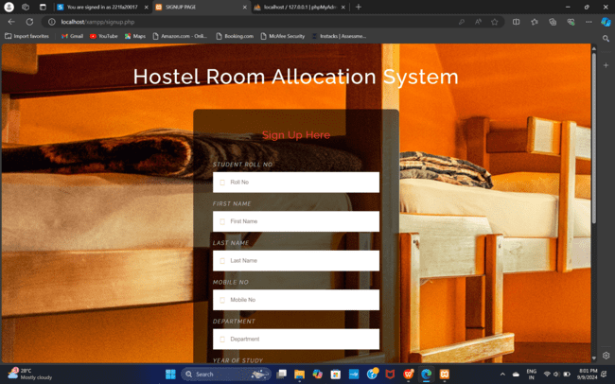

**Figure 7.2. Student registration sign up page screen shot**

**7.3 Dashboard**

Figure 7.3 shows the dashboard for the hostel management system, designed to provide both students and administrators with a comprehensive overview of relevant information. The dashboard features an intuitive layout that allows users to navigate easily between various sections, including accommodation details, payment status, and important announcements.

**Figure 7.3. Student dashboard screen shot**

**7.4 Alloted blocks**

Figure 7.4 illustrates the allotted blocks within the hostel management system, showcasing the various accommodation blocks designated for students. Each block is clearly labeled and provides essential information regarding its capacity, amenities, and occupancy status.

**Figure 7.4. Student Alloted Blocks screen shot**

**7.5 Fee payment form**

Figure 7.5 presents the fee payment form within the hostel management system, designed to facilitate a seamless payment experience for students. This form allows students to make their hostel fee payments quickly and securely, ensuring that all financial transactions are efficiently processed.

**Figure 7.5. Student Fee payment form screen shot**

**7.6 Allotment of Mess**

Figure 7.6 depicts the allotment of mess facilities within the hostel management system, outlining how meals are organized and assigned to students residing in the hostel. The mess allocation process is designed to ensure that all students receive nutritious meals and can choose their dining preferences conveniently.

**Figure 7.6. Student Attotment of mess screen shot**

**7.7 Profile info**

Figure 7.7 illustrates the profile information page within the hostel management system, where students can view and update their personal details. This feature is designed to empower students by giving them control over their information and ensuring that the hostel management has accurate and up-to-date records.

**Figure 7.7. Student Profile screen shot**

**7.8 Hostel manager/admin login**

Figure 7.8 illustrates the login page for hostel managers and administrators within the hostel management system. This secure login interface is designed to provide authorized personnel with access to administrative functionalities necessary for efficient hostel operations.

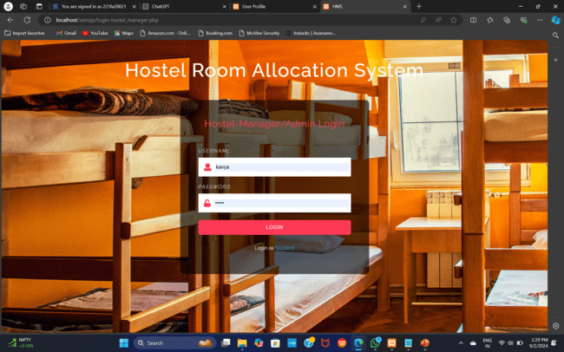

**Figure 7.8. Hostel manager login screen shot**

**7.9 Admin home**

Figure 7.9 presents the admin home page within the hostel management system, serving as the central hub for hostel administrators to manage all aspects of hostel operations efficiently. This intuitive interface provides quick access to essential functionalities and real-time data, enabling effective decision-making.

**Figure 7.9. Hostel manager home page screen shot**

**7.9.1 Appoint /Remove hostel manager**

Figure 7.9.1 illustrates the functionality for appointing and removing hostel managers within the hostel management system. This feature is crucial for ensuring effective administration and oversight of hostel operations, allowing for seamless transitions in management.

**Figure 7.9.1 Appointing Hostel manager home page screen shot**

**7.9.2 Students details dashboard :**

Figure 7.9.2 showcases the Students Details Dashboard within the hostel management system, designed to provide administrators with a comprehensive overview of all student information related to their hostel accommodation. This dashboard serves as a central hub for monitoring student data, facilitating effective management and support.

**Figure 7.9.2 Students details page screen shot**

**7.9.3 Students Attendance:**

Figure 7.9.3 illustrates the Students Attendance module within the hostel management system, designed to monitor and manage student attendance efficiently. This feature is essential for ensuring accountability and tracking student presence within the hostel environment.

**Figure 7.9.3 Students Attendance page screen shot**

**7.9.4 Admin profile**

Figure 7.9.4 displays the Admin Profile section within the hostel management system, which provides administrators with a personal profile interface to manage and update their account details. This feature ensures secure and personalized access to the system’s functionalities.

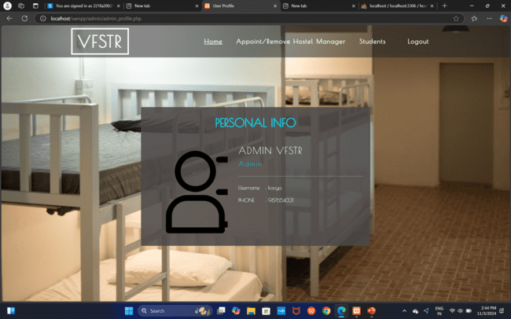

**Figure 7.9.4 Admin profile page screen shot**

**Conclusion :**

To conclude the description about the project : The project, developed using PHP and MySQL is based on the requirement specifcation of the user and the analysis of the existing system, with exibility for future enhancement. Last few years the educational institutions are increased rapidly. As a result for the accommodation of the students of these institutions, the number of hostel also increase. So it is very hard to do all the hostel management activities manually. There is a lot of strain on the person who are running the hostel. This hostel management software is designed for those people who want to manage hostel activities easily.This particular project deals with the problems on managing a hostel and avoids the problems which occur when carried manually.

**Future Work**

In this app, we already set a platform as the users want. We also take some user feedback. But it needs more user feedback. As much we get feedback it becomes easy to make this app more user-friendly. It needs to involve the authority to solve this kind of issue. We also need authoritys feedback to solve their issues

**Bibliography**

[1] EMMANUELADUBAFFOEJUNE. Hostel Management System. PhDthesis, 2016.

[2] Kola Ayanlowo, O Shoewu, Segun O Olatinwo, Olusegun O Omitola, and Damilola D Babalola. Development of an automated hostel facility management system. Journal of Science and Engineering, 5(1):0110, 2014.

[3] Kiplimo Changwony. Online hostel management system. 2015.

[4] AR Sujana. Hostel management system for Trincomalee Campus. PhD thesis, Fac ulty of Management and Commerce SEUSL, 2013.

[5] MUHAMMED SHAHEER KA. Hostel management system. 2010.

[6] Asadullah Khan and Sajid Rashid Ahmad. Desktop gis application for hostel man agement of punjab university lahore. Journal of Himalayan Earth Science, 45(2), 2012